**Operators**

An operator is a symbol that tells the compiler to perform specific mathematical or logical functions.

* Arithmetic Operators
* Relational Operators
* Logical Operators
* Bitwise Operators
* Assignment Operators
* Conditional Operators

**Arithmetic Operators:**

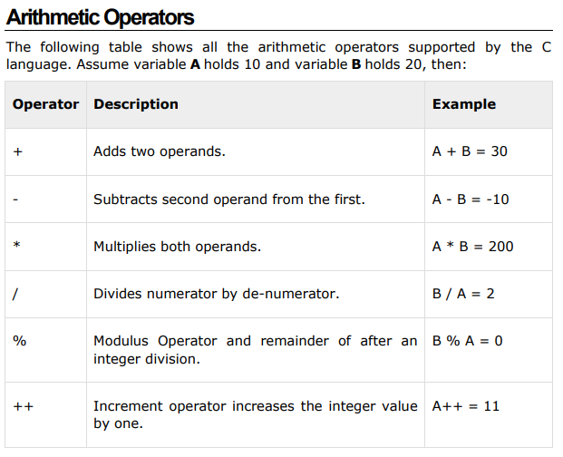

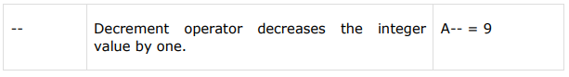

**Example:**

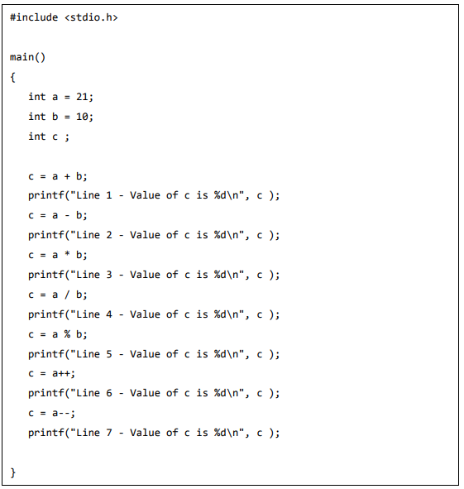

**Rational Operators:**

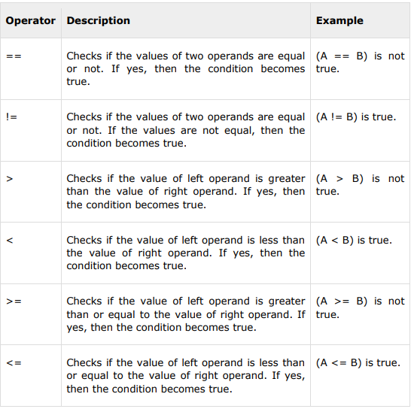

**Example:**

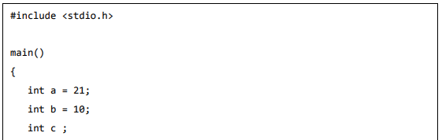

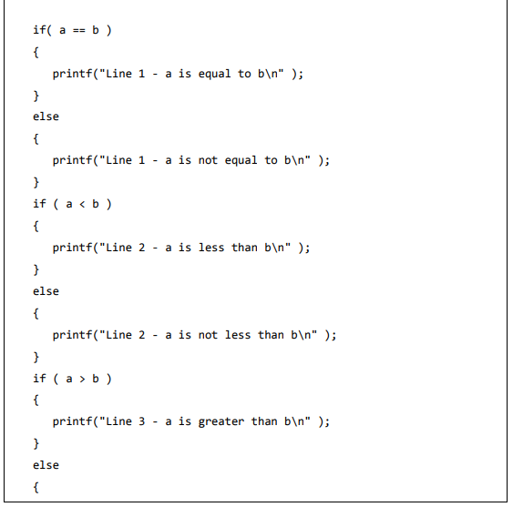

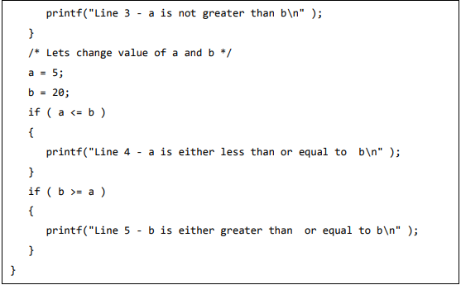

**Logical Operators:**

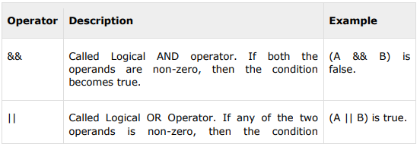

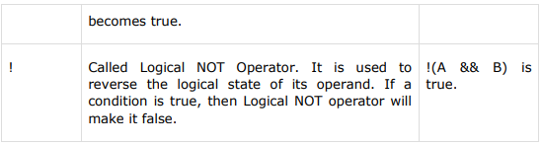

**Example:**

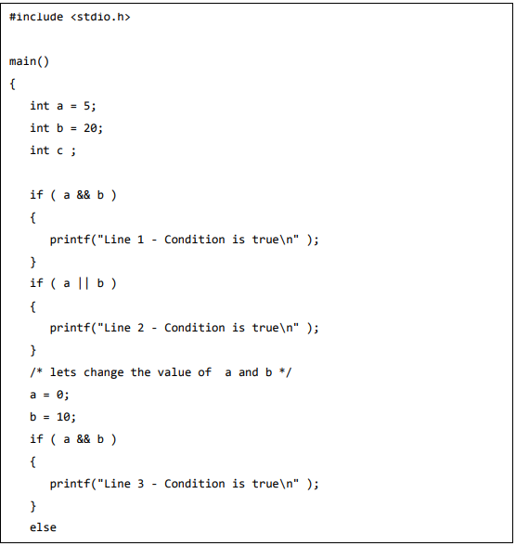

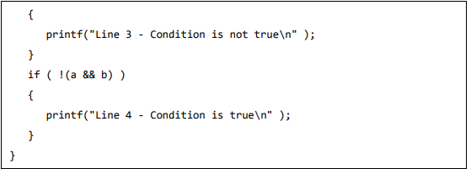

**Bitwise operators:**

Bitwise operators work on bits and perform bit-by-bit operation. The truth table for &, |, and ^ is as follows:

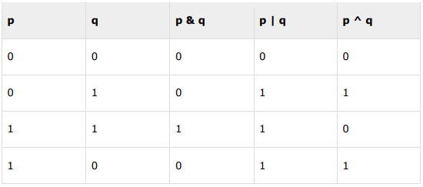

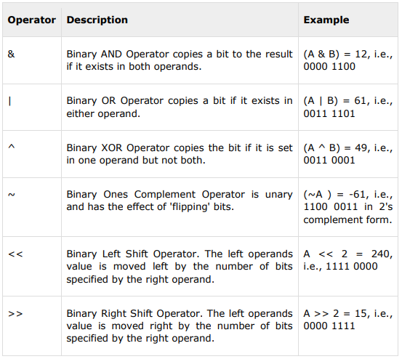

**Example:**

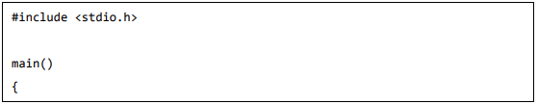

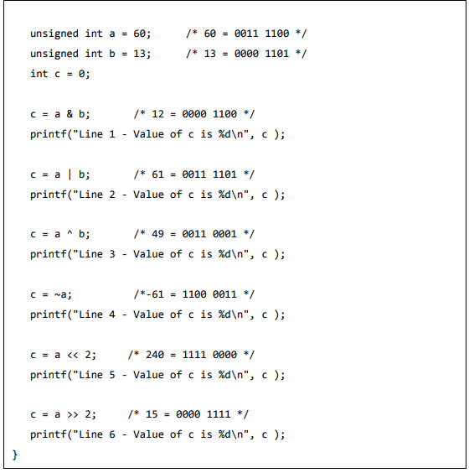

**Assignment operators:**

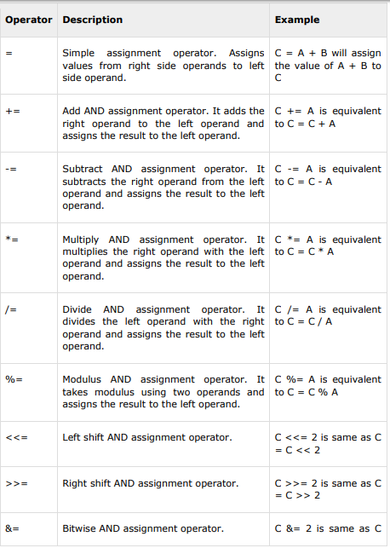

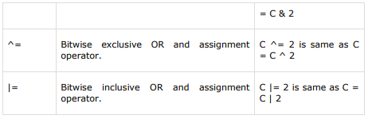

**Example:**

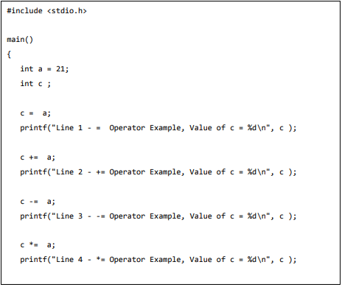

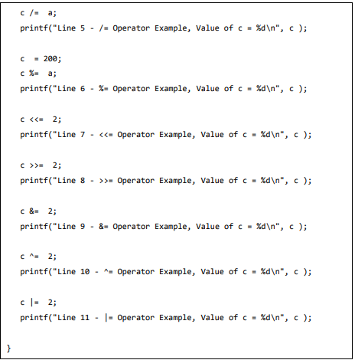

**Conditional Operators:**

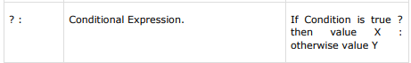

**Example:**

